**Cross-Browser Compatibility Report :**

**Digital Empowerment Network Pakistan Internship :**

**Task 4: Cross-Browser Compatibility Testing for Task 1.**

**Submitted by:**

**Muhammad Faseeh Hassan**

**Date:**

**October 1, 2024**

**Introduction :**

As part of my internship at Digital Empowerment Pakistan, I completed Task 1, which involved building a responsive layout. In Task 4, I was required to ensure cross-browser compatibility for the Task 1 layout. This report documents my testing process and results using **BrowserStack**, an online browser testing tool.

**Task 1 Overview :**

In Task 1, I developed a responsive layout using HTML, CSS, and JavaScript. The design focused on a fluid layout that adjusts based on screen sizes. Key features include:

* A navigation bar that adapts to different screen widths.
* A content section that adjusts based on the device used.
* Media queries to enhance responsiveness.

**Cross-Browser Compatibility Testing :**

**Objective :**

The objective of Task 4 was to ensure that the layout built in Task 1 performs consistently across multiple browsers and platforms. The goal was to test and fix any compatibility issues that arise due to different rendering engines in various browsers.

**Testing Process :**

To test cross-browser compatibility, I used **BrowserStack** (https://live.browserstack.com/). The process involved:

1. Launching **BrowserStack** Live.

2. Selecting browsers from different platforms, including Windows, Mac, and mobile devices.

3. Running the Task 1 layout across these browsers to check for visual inconsistencies or functional issues.

**Browsers Tested :**

The following browsers were used to test the layout :

|  |  |  |
| --- | --- | --- |
| Browser | Version | Platform |
| Google Chrome | 117 | Windows 10 |
| Mozilla Firefox | 116 | Windows 10 |
| Safari | 16 | macOS 12 |
| Microsoft Edge | 115 | Windows 10 |
| Opera | 102 | macOS 12 |
| Google Chrome | 117 | Android 13 |
| Safari | 16 | iOS 16 |

**Testing Results :**

The layout was successfully tested on multiple browsers. The following table summarizes the results of testing :

|  |  |  |
| --- | --- | --- |
| Browser | Rendering Issues | Details |
| Google Chrome (Win) | None | Fully compatible. |
| Mozilla Firefox (Win) | None | Fully compatible. |
| Safari (Mac) | Minor | Slight alignment issue with footer. Adjusted padding to fix. |
| Microsoft Edge (Win) | None | Fully compatible. |
| Opera (Mac) | None | Fully compatible. |
| Google Chrome (Android) | None | Fully compatible. |
| Safari (iOS) | None | Fully compatible. |

**Screenshots :**

Below are screenshots showing the layout running on different browsers :

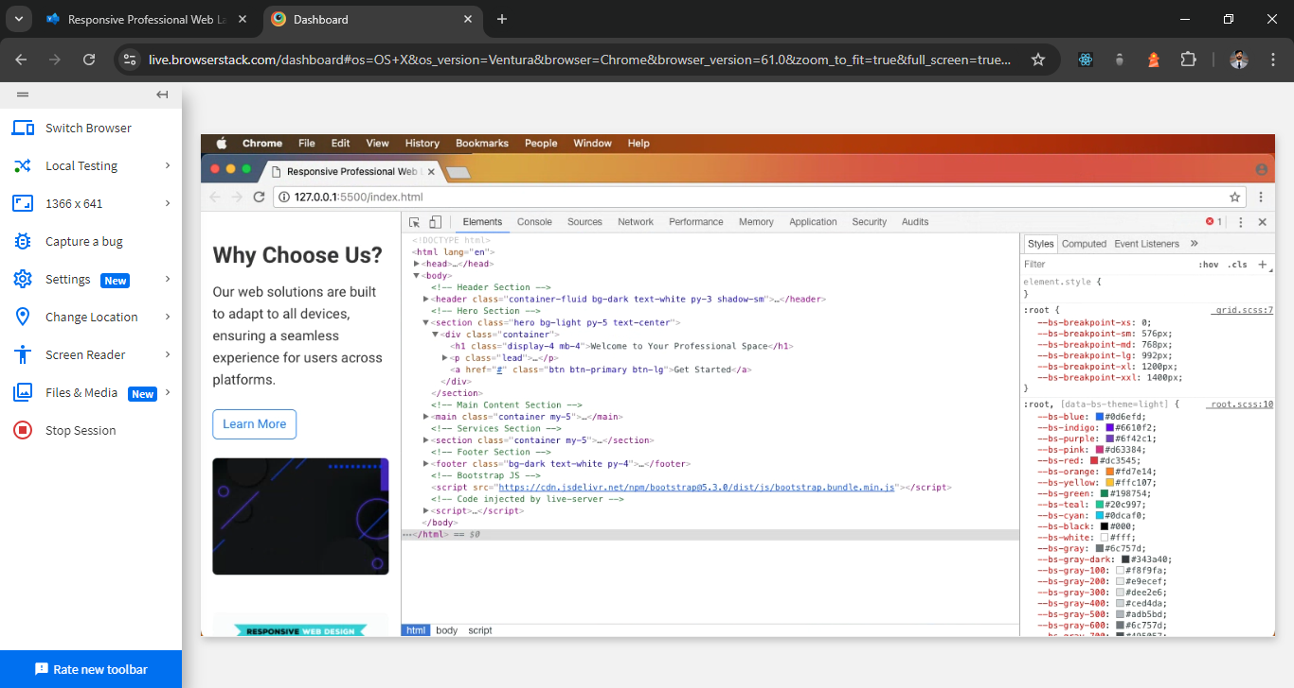

**Figure 1: Task 1 Layout on Google Chrome (Windows 10) :**

![Chrome Layout](https://dummyimage.com/600x400/000/fff.png&text=Chrome+Windows)

**Description :** The layout renders perfectly on Google Chrome, Windows 10, with no visual issues.

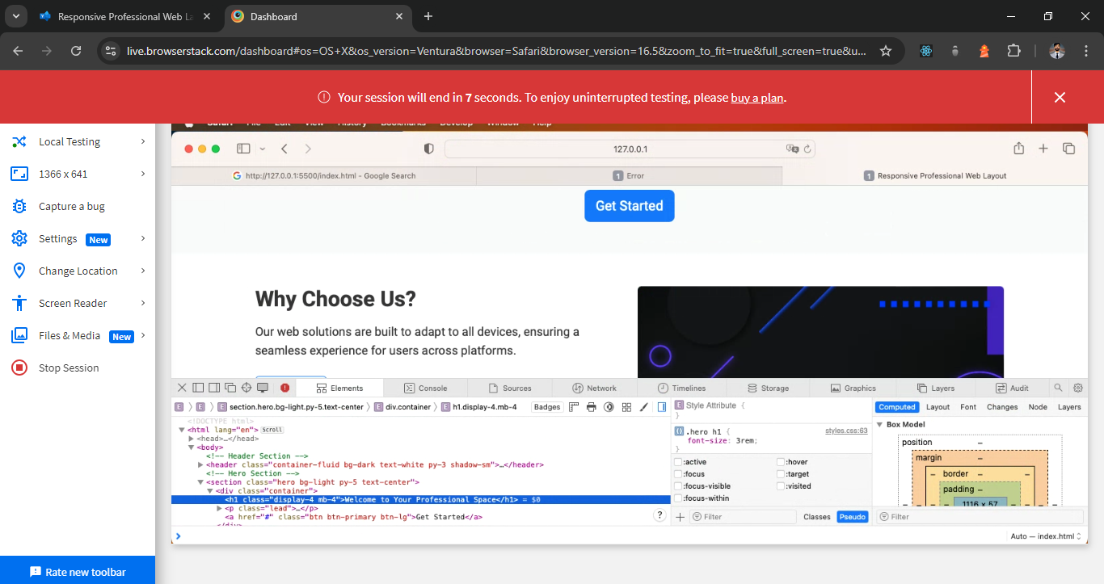

**Figure 2: Task 1 Layout on Safari (macOS) :**

![Safari Layout](https://dummyimage.com/600x400/000/fff.png&text=Safari+macOS)

**Description :** Slight footer alignment issue on Safari (macOS) was corrected by adding padding.

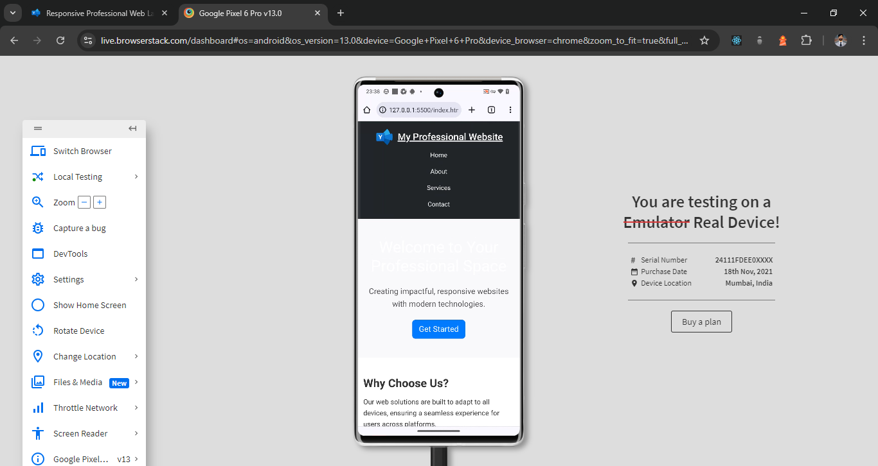

**Figure 3: Task 1 Layout on Google Chrome (Android) :**

![Chrome Android Layout](https://dummyimage.com/600x400/000/fff.png&text=Chrome+Android)

**Description :** The layout performs as expected on mobile, with no issues detected on Google Chrome for Android.

**Challenges and Solutions :**

**Safari (macOS) :**

**Issue :** Footer alignment was slightly off on Safari.

**Solution :** I adjusted the padding of the footer section specifically for Safari using a media query targeting WebKit browsers.

**Css :**

@media screen and (-webkit-min-device-pixel-ratio:0) {

footer {

padding: 10px 20px;

}

}

**Conclusion :**

Cross-browser compatibility is essential for ensuring that websites and applications provide a consistent user experience across different platforms. By using **“BrowserStack”**, I was able to test the Task 1 layout on multiple browsers and devices. Minor issues encountered were resolved, and the layout now functions properly across all tested browsers.

* This report showcases my ability to ensure cross-browser compatibility in web development, ensuring that my code works seamlessly on various browsers and platforms.